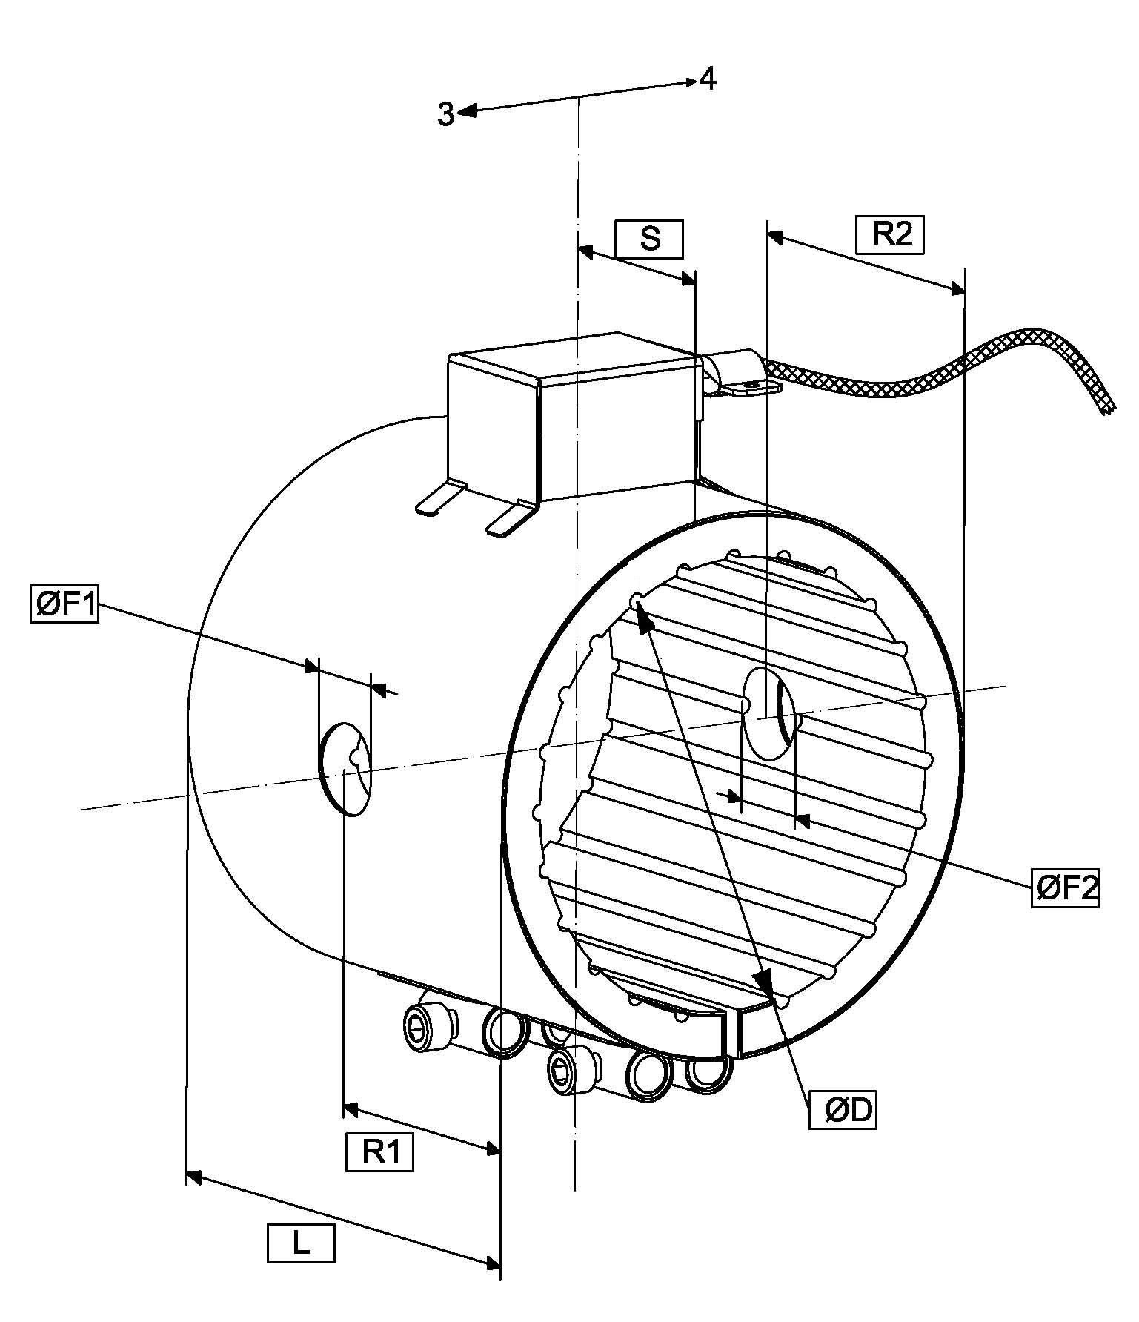
CABLE EXIT DIRECTION

DEFINITION SIDE

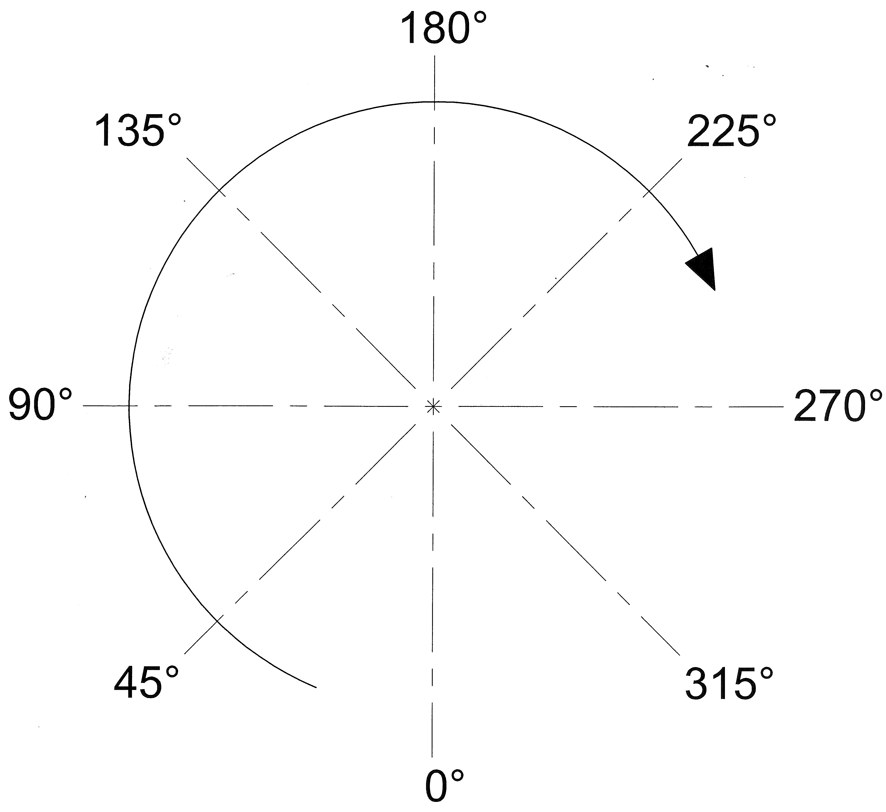

TERMINAL BOX CONNECTION AND HOLE POSITION

Diameter ØD
Length L
Voltage supply [V]
Power [W]
Kind of board
Position of Board in degree |  |  |  |  | Dimension S
Cable exit direction [3-4]
Cable length
Hole 1 position in degree |  | Dimension R1 |  |  |  | Dimension ØF1
Hole 2 position in degree |  | Dimension R2 |  |  |  | Dimension ØF2
Hole 3 position in degree |  | Dimension R3 |  |  |  | Dimension ØF3
All the dimension without measurement units are in [mm]

